**2022_**“**ShuWei Cup**”

**2022_“舒威杯”**

Problem B：Red VS. Blue

问题B:红色对蓝色

In modern war, both offensive and defensive sides need to introduce efficient war strategies to increase war threats and reduce losses. Only by forming a relatively stable and balanced war dynamics can the ultimate goal of reaching consensus be realized as soon as possible.

现代战争中，攻防双方都需要引入高效的战争策略，以增加战争威胁，减少损失。只有形成相对稳定均衡的战争动态，才能尽快实现达成共识的最终目标。

In view of the above war problems, consider the following simplification of the Red VS. Blue war problem: assuming that the Red and the Blue are engaged in the battle as shown in Figure 1, the two parties can only conduct the initial platoon in the position with the same color, and each node has its own attack difficulty. The more difficult the attack is, the larger the circle radius in Figure 1, you need to provide the optimal battle strategy for each party based on the actual number and characteristics of the two parties' military weapons.

针对以上战争问题，考虑以下对红蓝大战问题的简化:假设红蓝双方进行如图1所示的战斗，双方只能在颜色相同的阵地进行初始排，每个节点都有自己的攻击难度。攻击难度越大，图1中的圆圈半径越大，你需要根据双方军事武器的实际数量和特点，为每一方提供最优的作战策略。

The main fighting units on both sides are infantry, and the main weapons are light tanks with mobility and concealment, medium tanks with balanced firepower and mobility, heavy tanks with heavy armor and powerful firepower, self-propelled artillery with ultra-long-range striking ability and powerful fire support, strategic bombers (not too many units should be deployed to prevent bombing) and anti-aircraft artillery (each side can set up 10 anti-aircraft points). The Red has 1.25 million infantry, 500 drones, 180 heavy tanks, 300 medium tanks, 420 light tanks and 7000

双方主要作战单位为步兵，主要武器为具有机动性和隐蔽性的轻型坦克、火力和机动性均衡的中型坦克、装甲厚重火力强大的重型坦克、具有超远程打击能力和强大火力支援的自行火炮、战略轰炸机(为防止轰炸应部署不太多单位)和高射炮(每方可设置10个防空点)。红军有125万步兵、500架无人机、180辆重型坦克、300辆中型坦克、420辆轻型坦克和7000辆

self-propelled guns. The Blue has 1 million infantry, 300 drones, 340 heavy tanks, 570 medium tanks, 800 light tanks, and 14,000 self-propelled guns. See Attachment 2 for the specific parameters of the Red and the Blue weapons. Please solve the following three problems through appropriate simplified assumptions and mathematical modeling methods:

自行火炮。蓝军有100万步兵，300架无人机，340辆重型坦克，570辆中型坦克，800辆轻型坦克，14000门自行火炮。红蓝武器的具体参数见附件2。请通过适当的简化假设和数学建模方法解决以下三个问题:

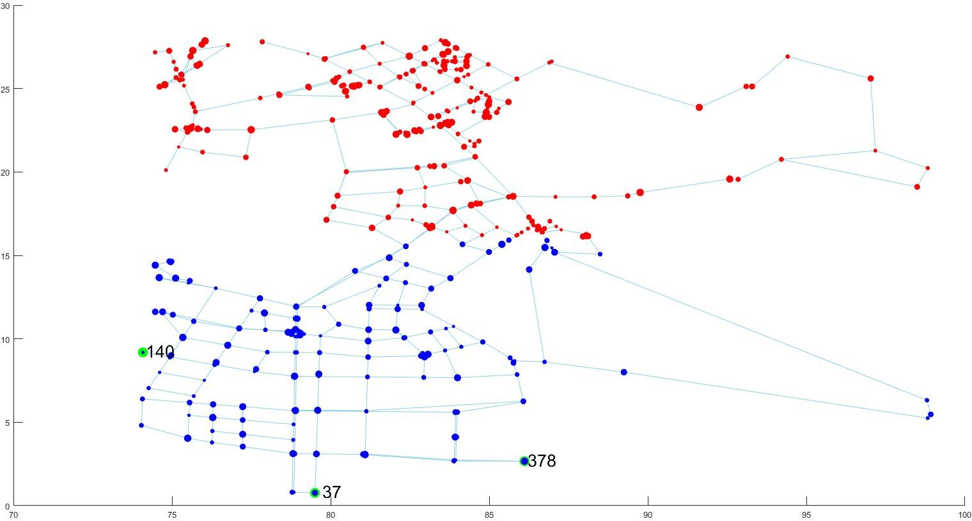



# Figure 1 Assignable nodes for the Red and Blue

# 图1红色和蓝色的可分配节点

**Question 1:** Based on the data in Annex 1 and Annex 2, and considering the attack difficulty, march distance, weapon range and air defense deployment of each node, please work out the assigned positions and quantity scale of infantry, tanks, self-propelled artillery and air defense

问题1:根据附件1和附件2中的数据，并考虑各节点的攻击难度、行军距离、武器射程和防空部署，请计算出步兵、坦克、自行火炮和防空的分配位置和数量规模

artillery of both sides, as well as the optimal command positions and several alternative positions of both sides.

双方的炮兵，以及双方的最佳指挥阵地和几个备选阵地。

# Question 2:

# 问题2:

Based on the optimization results of question 1, you need to build the optimization model of medical supplies, military supplies and daily supplies distribution and supply for both the Red and Blue. At the same time, on the basis of fully considering the potential attack strategy from the other side, the key information such as the total number of workers and vehicles required in the non-supply mode is provided during the modeling. Finally, you need to provide the optimal supply plan of the Red and the Blue in the form of tables or graphs in the text.

根据问题1的优化结果，您需要为红蓝双方建立医疗用品、军事用品和日常用品配送和供应的优化模型。同时，在充分考虑来自对方的潜在攻击策略的基础上，在建模时提供了非供应模式下所需的工人和车辆总数等关键信息。最后，你需要在文本中以表格或图表的形式提供红色和蓝色的最佳供应计划。

# Question 3:

# 问题3:

In combination with the previous two questions and in the case of the Red attacking and the Blue defending, please propose the Red’s better attack plan and the Blue's better retreat plan. Given that the retreat node of the Blue is [37,140,378], what are the different overall retreat plans of the Blue in the case of good communication and communication interruption?

结合前两个问题，在红队进攻和蓝队防守的情况下，请提出红队的较好进攻方案和蓝队的较好撤退方案。给定蓝方的撤退节点为【37，140，378】，在通讯良好和通讯中断的情况下，蓝方的整体撤退方案有哪些不同？